**Steps to run:**

1. Make sure to keep the executable LoadBalancerModified.exe and the file xmlFile_Raw.xml in same folder.
2. Click on the executable file LoadBalancerModified.exe to run it.
3. The file will open in CMD prompt. Click enter to continue.
4. The program will ask for load details like start range, end range, process name.
5. When you enter the loads to be skipped, enter them space separated. (Ex: 43 50 53)
6. Enter the details and press enter.
7. Repeat for other XML files.

**Sample Output:**

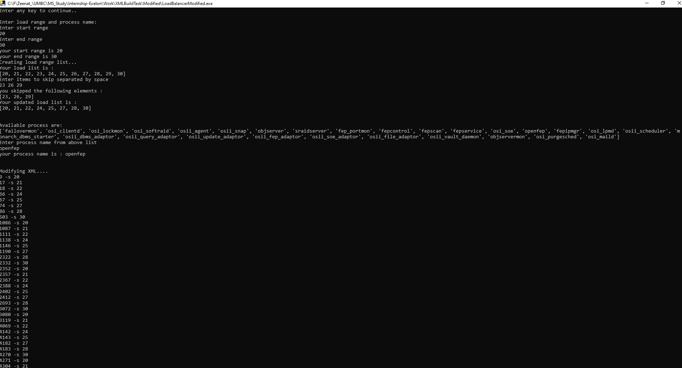

**Sample Output XML file:**



Attached files:

